<Your member names and IDs>

<Your solution>

Nguyen Le Nhat Duong - 1952638

Huỳnh Minh Trí - 1953041

Bui Hoang Phuc - 1952925

1. **Main:** procedure/function: sub2, sub1

Variables: a // 2, b // 2, c// 2

**Sub1:** procedure/function: sub3, sub1, sub2

Variable: a//7, b//2, c//2

**Sub2**: procedure/function: sub1, sub2

Variable: a//2, b//3, c//3, f//3

**Sub3:** procedure/function: sub3, sub1,sub2

Variable: a//7, b//8, c//2

1. a//2 : main, sub2

b//2: main,sub1

c//2: main, sub1, sub3

b//3: sub2

a//7: sub1, sub3

b//8: sub3

Sub1: main, sub1, sub2, sub3

Sub3: sub1, sub3

c) Activation records that reaches line 10 in second time

| main | sub1 | sub2 | sub3(Does not exist anymore at this time) | sub3 |
| --- | --- | --- | --- | --- |
| a=0 | a=3 | b=1 | b=2 | b=1 |
| b=1 |  | c=2 |  |  |
| c=4 |  | f = sub3 |  |  |
|  |  |  |  |  |

When reach line 17

| main |  |  |  |  |  |
| --- | --- | --- | --- | --- | --- |
| a=0 |  |  |  |  |  |
| b=8 |  |  |  |  |  |
| c=4 |  |  |  |  |  |
|  |  |  |  |  |  |

Question 2:

| main | sub1 | sub2 | Sub3 first | Returns back to sub2 | Returns back to sub1 | Returns back to main |
| --- | --- | --- | --- | --- | --- | --- |
| a -> o1: 0 | a->o4: 3 | a->o4: 3  (Different from static scope) | a->o4: 3 | Return  (f(c) - f(b))*2  = (5 - 4)*2  = 2 | b:= sub2(1,2,sub3)  = 2 | print(b)  ⇒ print 2 |
| b -> o2: 1 | b -> o2: 1 | b-> o5: 2 | b -> o8: 2 |  |  |  |
| c -> o3: 4 | c -> o3: 4 | c -> o6: 1 | c -> o6: 1 |  |  |  |
|  |  | f -> o7: sub3 | Returns (b*c) + a = 5 |  |  |  |
|  |  |  | Sub3 second |  |  |  |
|  |  |  | a->o4: 3 |  |  |  |
|  |  |  | B -> o9: 1 |  |  |  |
|  |  |  | c -> o6: 1 |  |  |  |
|  |  |  | Return (b*c) + a =4 |  |  |  |

Đỗ Đăng Khoa - 1952295

Lê Minh Khôi - 1952076

Quách Đằng Giang - 1952044

A,

Main: a//2,b//2,c//2,sub1//7,sub2//3

Sub1:a//7,sub3//8,b//2,c//2,sub2//3,sub1//7

Sub2:a//2,b//3,c//3,f//3,sub1//7,sub2//3

Sub3:a//7,b//8,c//2,sub1//7,sub2//3,sub3//8

B,

a//2: Main,sub2,

b//2: Main,sub1

c//2:main,sub1,sub3

b//3: sub2

a//7:sub1,sub3

b//8: sub3

sub1:Main,sub1,sub2,sub3

sub3:sub1,sub3

C,

At line 17, the value of b is **8**

Call **main**:

Call **sub1(3)**:

=> local var a = 3

Call B := sub2(1,2,sub3) = **8 (B not declared in sub1 => B//2)**

Call **Sub2(1,2,sub3)**:

=> local var b = 1, var c = 2, f = sub3

Call Sub2 := (f(c) - f(b)) * 2 = (11 - 7) * 2 = **8**

Call **f(c)** = Sub3(c) = Sub3(2)

=> local var b = 2

Call sub3 := b*c+a = 2*4+3 = **11**

Call **f(b)** = Sub3(b) = Sub3(1)

=> local var b = 1

Call sub3 := b*c+a = 1*4+3 = **7** // line 10 second time

| main | sub1 | sub2 | sub3 (second time) |
| --- | --- | --- | --- |
| a=0 | a=3 | b=1 | b=1 |
| **b=1** |  | c=2 | **sub3=5** |
| c=4 |  | f=sub3 |  |
|  |  | **sub2=8** |  |

Question 2:

**Call main**

a=0, b=1, c=4 // local variable

**Call sub1(3)**

a=3 // local variable

~~b=1,c=4 // use `b` and `c` from main, nearest activation record~~

b := sub2(1,2,sub3)

**Call sub2(1,2,sub3)**

b= 1 // local variable

c= 2 // local variable

f = sub3 // local variable

sub2 := (f(c) - f(b))*2

**Call f(c) = sub3(2)**

b=2 // local variable

a=3 // use `a` from sub1, nearest activation record

c=2 // use `c` from sub2, nearest activation record

sub3:= b*c + a = 2*2+3 = **7**

**Call f(b) = sub3(1)**

b=1 // local variable

a=3 // use `a` from sub1, nearest activation record

c=2 // use `c` from sub2, nearest activation record

sub3:= b*c + a = 1*2+3 = **5**

**sub2 := (7-5)*2 = 4**

**b := 4 // assign to `b` from main, nearest activation record**

print(b) // value of b at line 17 is 4

Nguyễn Minh Tâm - 1952968

Lương Duy Hưng - 1952747

Ho Trí Kháng - 1952069

1.

1. Static referencing environment of procedure main:   
   a//2, b//2, c//2, sub1, sub2

Static referencing environment of procedure sub1:  
a//7, b//2, c//2, sub1, sub2, sub3

Static referencing environment of procedure sub2:

a//2, b//3, c//3, f//3, sub1, sub2

Static referencing environment of procedure sub3:

a//7, b//8, sub3

1. Scope of declaration a//2:  
   main, sub2

Scope of declaration b//2:

main, sub1

Scope of declaration c//2:  
main, sub1, sub3

Scope of declaration b//3:

sub2  
Scope of declaration a//7:

sub1, sub3

Scope of declaration b//8:

sub3

Scope of declaration sub1:

main

Scope of declaration sub3:

sub1

1. Existing activation records when program main is executed and the execution reaches line 10 in the second time:

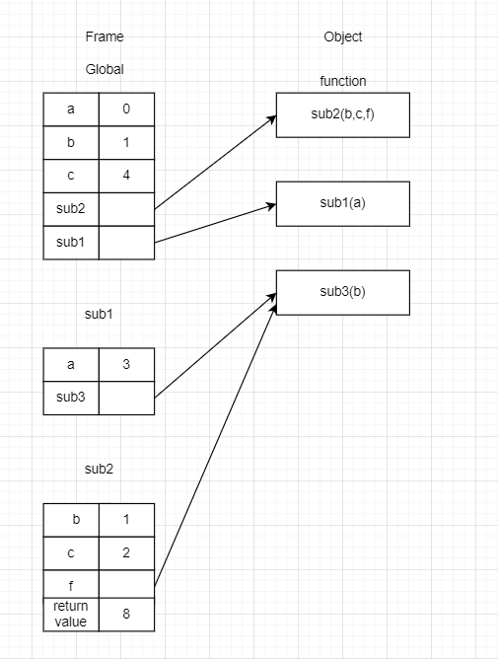

After the code reaches line 17, variable b is assigned by sub1 with value 8.

Because b is the global variable and the following is the current state

2) Assume dynamically-scoped language:

The value of b = 0 because the dynamically-scoped language will keep the state of the most recently executed b that is not destroyed, which is the variable b from the function sub1 (line 13)

main: a = 0, b = 1, c = 4

sub1: a = 3, ~~b = 1, c = 4~~

sub2: ~~a = 3,~~ b = 1, c = 2, f = sub3

-> sub3(2): ~~a = 3,~~ b = 2~~, c = 2,~~ return value = 7 (f(c) - f(b)) * 2

After passing c = 2 to param c of sub3, parameter b (line 8) changes the value to 2, back to sub2:

-> sub2: a = 3, b = 2, c = 2

-> sub3(2): a = 3, b = 2, c = 2, return value = 7

sub2: a = 3, b = 2, c = 2, return value = 0

sub1: a = 3, b = 0, c = 2

main: a = 3, b = 0, c = 2

Vo Ngoc Sang - 195230

Nguyễn Luật Gia Khôi - 1952079

Phạm Bùi Minh Huân - 1952056

**Question 2:**

a = 0, b = 1, c = 4

Call sub1:

a = 3

Call sub 2:

b = 1

c = 2

f = sub3

Call sub3:

b = 2

sub3 = b * c + a = 2*2+3 = 7 // where b, c, a

Call sub3:

b = 1

sub3 = 1*2 + 3 = 5 // the same as before

sub2 = (7-5) * 2 = 4

b = 4 // where b ?

=> print(b) # 4

Lâm Minh Quân -1952114

Bui Quang Tien - 1953018

a) main: a//2, b//2, c//2, sub2, sub1

sub1: a//7, b//2, c//2, sub3, sub1

sub2: a//2, b//3, c//3, f//3, sub2, sub1

sub3: a//7, b//8, c//2, sub1, sub3, sub2

b) a//2: main, sub2

b//2: main, sub1

c//2: main, sub1, sub3

b//3: sub2

a//7: sub1, sub3

b//8: sub3

sub1: main, sub1, sub2, sub3

c)

After reaching line 10 in the second time

| main | sub1 | sub2 | sub3 ( in second time) |  |
| --- | --- | --- | --- | --- |
| a:0 | a:3 | b:1 | b:1 |  |
| b:1 |  | c:2 | sub3: 7 |  |
| c:4 |  | f: sub3 |  |  |
|  |  |  |  |  |

2)

The value of b printed is 4 because

| main | sub1 | sub2 | sub3(second time) | sub3(first time) |
| --- | --- | --- | --- | --- |
| a:0 | a:3 | c:2 | a:3 | a:3 |
| b:1 |  | f: sub3 | b:2 | b:1 |
| c:4 |  |  | c:2 | c:2 |
|  |  |  | sub3: 7 | sub3: 5 |
|  |  |  |  | sub2: 4 |

b = 4 , which is assigned to the nearest activation record

=> The value of print(b) in line 17 is 4

Ho Tri Khang - 1952069

**a)**

main: a//2,b//2,c//2,sub2,sub1

sub1: a//7, sub3, b//2, c//2,sub1

sub2: b//3,c//3,f//3,a//0,sub2,sub1

sub3: a//7, b//8, c//2,sub1,sub3,sub2

**b)**

a//2:: main, sub2, sub1, sub3

b//2: main, sub1

c//2: main, sub1, sub3

b//3: sub2

a//7: sub1, sub3

b//8: sub3

sub1: sub1, sub3

sub3: sub3

**c)**

